New Testament Backgrounds
EBC Summer 2012
Class Notes

Introduction: Why Study New Testament Backgrounds?

- Hermeneutical Necessity

  - Historical, Grammatical, Literary method

  - Context: Literary AND Historical

- Cultural and Theological Differences

“The various books of the New Testament were written to real people who knew their own history and culture. If we do not try to put ourselves into the context of the original readers of the Scriptures, we can very easily read our own culture into a passage and reach wrong conclusions about what it meant to the author and therefore what it should mean to use” (Jeffers, 293)

  - Problem of 3 cultures:

What is New Testament Backgrounds?

- An examination of the historical, theological, and social environment in which the New Testament was written.

- Historical Timeline

What are the sources for learning the Background?

Some of the most significant sources include:

- The Apocrypha

- The OT Pseudepigrapha

- The Dead Sea Scrolls

- Philo

- Greco-Roman Literature

- Josephus

  - 2nd main source for 2nd Temple History

    - Life

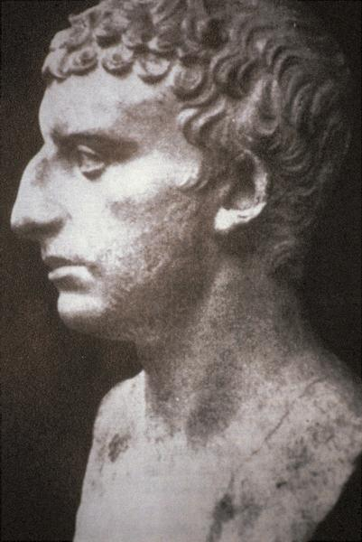

    - 4 Books

Figure 1 Flavius Josephus

Part 1: History of the Second Temple Period

- Persia to Greece (538 BC – 333 BC)

  - Israel returns under Cyrus

- Persian rule vs. Babylonian?

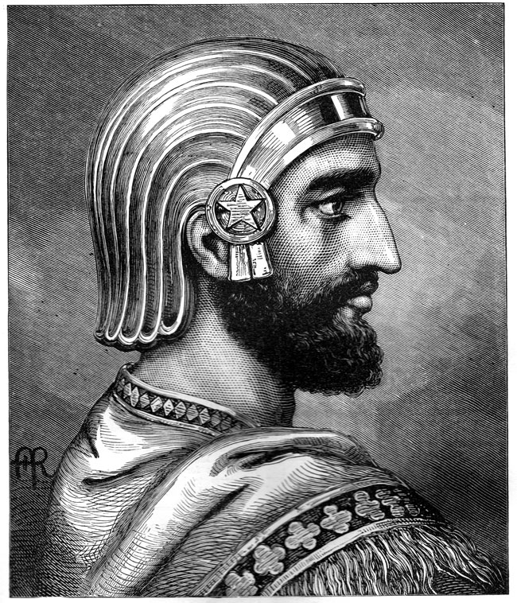

- Israel was back in the land, but not restored.

      - temple

      - nation

      - land

      - obedience?

      - Most of all: they were not a politically independent state.
Figure 2 Cyrus the Great

- Authority given to High Priest.

- Judea: The New Jewish Center

  - Persian Rule Brought Many Changes:

- Individualism

    - without political independence, Israel would begin to loose its nationalistic outlook.

“A new sense of personal pride at least partially replaced the old sense of national pride. Entrepreneurism flourished as Jewish businessmen found new opportunities for commerce, and new technologies were producing a wide array of goods. Democracy of a sort was extended as the Jewish ‘council of elders’ began to take on tasks of government previously handled by the king and his officers. And new forms of literary and artistic expression came into being as Jewish thought was cross-pollinated with ideas and styles form the many lands that lived under the umbrella of Persian rule” (Tomasino, 71).

- Linguistic changes

- Hebrew continued to be spoken, though it became to be used primarily as a written language (DSS, Mishnah) (see Tomasino, 72).

- Focus on the Written Word

  - prophetic office began to give (esp. 2nd temple period) way to the written word

  - already prevalent in Ezra/Neh

- Theological Ideas

  - Detailed description of Angels and Demons

Old Testament

- Angels

- Demons

Early Judaism

- Early Jewish literature

- New Testament

- Fall of Satan

  - no “devil” in OT

  - “Satan” in Job 1 and Zech 3 = hasatan “the adversary,” not a personal name (see too 1 Sam 29:4; 1 Kings 5:4; even Numb 22:22, 32).

  - “Satan” a proper name only in 1 Chron 21:1 (written during the Persian period)

  - Early Jewish lit:

    - Jubilees: “Mastema” (cf. only Hosea 9:8, “hatred”) is the chief evil spirit, influences people to do evil things

    - 1 Enoch: Azazel is “the Devil”

    - Test. 12 and DSS: the devil is “Belial”

  - Afterlife

- It is the corporate destiny of the nation, not the personal destiny of the individual, that is the OT’s main concern.

- Questions of the individual came late

  - Ezekiel 18

  - Wisdom Lit. (Proverbs, Eccl, Job, cf. some Psalms)

- Afterlife in the OT?

  - sheol = not hell, but a place where both the righteous and unrighteous go (Hezekiah, Isa 38:18; Job, Job 7:8-9; Jacob, Gen 37:35; Ps. 6:5; Eccl. 3:16-22; 9:10

  - Some references to afterlife = Isa 26:19; Dan 12:2; Ps 49:15 (probably late)

- Afterlife in Early Judaism?

  - Some books maintain no belief in afterlife

    - 1 Macc; Tobit; Sirach

  - Other books believed in afterlife and bodily resurrection

    - 2 Macc 7; 12

    - 1 Enoch

    - Pss. Sol.
Bodily Resurrection? 2 Macc 14

37 A certain Razis, one of the elders of Jerusalem, was denounced to Nicanor as a man who loved his compatriots and was very well thought of and for his goodwill was called father of the Jews. 38 In former times, when there was no mingling with the Gentiles, he had been accused of Judaism, and he had most zealously risked body and life for Judaism. 39 Nicanor, wishing to exhibit the enmity that he had for the Jews, sent more than five hundred soldiers to arrest him; 40 for he thought that by arresting he would do them an injury. 41 When the troops were about to capture the tower and were forcing the door of the courtyard, they ordered that fire be brought and the doors burned. Being surrounded, Razis upon his own sword, 42 preferring to die nobly rather than to fall into the hands of sinners and suffer outrages unworthy of his noble birth. 43 But in the heat of the struggle he did not hit exactly, and the crowd was now rushing in through the doors. He courageously ran up on the wall, and bravely threw himself down into the crowd. 44 But as they quickly drew back, a space opened and he fell in the middle of the empty space. 45 Still alive and aflame with anger, he rose, and though his blood gushed forth and his wounds were severe he ran through the crowd; and standing upon a steep rock, 46 with his blood now completely drained from him, he tore out his entrails, took them in both hands and hurled them at the crowd, calling upon the Lord of life and spirit to give them back to him again. This was the manner of his death.

  - Zoroastrian influence?

- similar beliefs

  - example: Tobit (written late in the Persian period), Asmodeus, a demon who torments a woman by killing the men she marries. This demon is similar to the popular Persian demon, Aeshma deava (“demon of wrath”)

  - example: Test. Abr. 20:9-12 = soul resides with the body for 3 days after death is directly paralleled in Zoroastrian thought

- Did Judaism pick up certain beliefs from Zoroastrian?

  - “…contact with the Persians inspired the Jewish sages to consider aspects of their faith that simply hadn’t received the attention they deserved. Some Jewish authors actually adopted ideas from Zoroastrianism to clarify their understanding of God. But in every case, any new ideas that came into Judaism during this period had to prove themselves in the light of the Scriptures, the accepted Word of the Lord” (Tomasino, 102).

  - Summary

- Greece to the Macabean Revolt (333 BC – 167 BC)
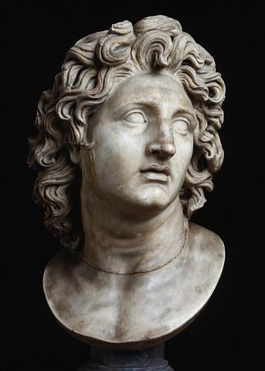
  - Alexander the Great Conquers Darius III of Persia

- Persia had a massive empire

- Darius III, in particular, was a tyrant who ruled with a heavy hand and displayed somewhat weak military tactics.

Figure 2 Alexander the Great

- Greece was a collection of city-states that often warred with each other, but Philip of Macadonia united all of Greece under his rule.

  - Hellenization

- Alexander set out as a Greek “missionary” to the East

- Much more impressed with the Eastern culture, so he ended up blending both the Greek and Eastern ways.

  - “No more would Hellenism simply mean the importation of Greece to Asia. Now it would mean a hybrid culture combining the best that Greece and the East had to offer” (Tomasino, 109).

- Can’t underestimate the Greek influence on the world.

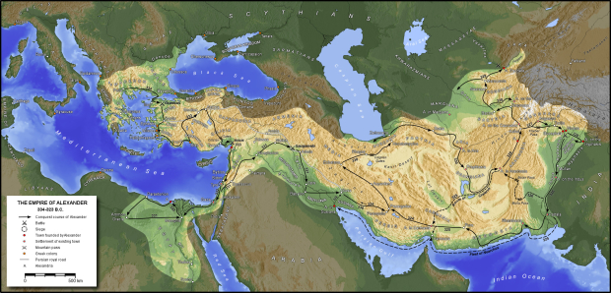
- Rome would end up conquering Greece, politically; but culturally, Greece conquered Rome.
Figure 3 Alexander's Empire

  - Alexander’s death (323 B.C.)

- three generals emerged: Lysimachus (Thrace and Asia Minor), Ptolemy (Egypt and Palestine), Seleucus (Syria and Mesopotamia).

- The two that are important for the land of Israel are _______________________________ and

_________________________.

- Ptolemaic Rule (ca. 300 – 200 B.C.)

  - Ptolemaic rule over Palestine was relatively calm.

  - Highly coveted piece of land (land bridge)

  - There were 4 significant wars between the Seleucids and Ptolemies during this time (300-200). After the 4th war (217; cf. Dan. 11:10-12), the Ptolemies were weakened, and in 200 B.C., the Seleucids finally took control of Palestine.

- Seleucid Rule over Palestine (200 – 142 B.C.)

  - The Seleucids, unlike the Ptolemies, were much more into Alexander’s vision of “Hellenizing” the East, and they were much more intrigued by Eastern customs. At the beginning of their rule, they were much more favorable to their subjects.
“There was such an extreme of Hellenization and increase in the adoption of foreign ways because of the surpassing wickedness of Jason, who was ungodly and no true high priest, that the priests were no longer intent upon their service at the altar. Despising the sanctuary and neglecting the sacrifices, they hurried to take part in the unlawful proceedings in the wrestling arena after the signal for the discus-throwing, disdaining the honors prized by their ancestors and putting the highest value upon Greek forms of prestige” (2 Macc. 4:13-15).

  - After Seleucids took over, the Jewish High Simon II (son of Onias) was restored to his position. But the Ptolomies previously had given a certain amount of political power to a wealthy family named the Tobiad’s. So these two groups would compete for power in Palestine.

  - Feuds and squabbles between 190-174 (2 Macc 3-4)

  - Rise of Antiochus IV

“When Seleucus died and Antiochus, who was called Epiphanes, succeeded to the kingdom, Jason the brother of Onias obtained the high priesthood by corruption, promising the king at an interview 360 talents of silver, and from another source of revenue 80 talents. In addition to this he promised to pay 150 more if permission were given to establish by his authority a gymnasium and a body of youth for it, and to enroll the people of Jerusalem as citizens of Antioch. When the king assented and Jason came to office, he at once shifted his compatriots over to the Greek way of life” (2 Macc. 4:7-10)
  - 174 Seleucus the IV was assassinated (by Heliodorus), and Antiochus IV was installed as the new king.

  - Daniel 11:25-45.

  - When Antiochus Ephiphanes (hereafter A.E.) became king, there was a constant battle for the high priesthood, not out of religious piety, but because of its key financial and political position.
Jewish High Priests from 320 – 159 B.C.

Onias I, son of Jaddua, ca. 320-280 BC
Simon I, son of Onias, ca. 280-260 BC
Eleazar, son of Onias, ca. 260-245 BC
Manasseh, son of Jaddua, ca. 245-240 BC
Onias II, son of Simon, ca. 240-218 BC
Simon II, son of Onias, 218-190 BC; praised by Ben Sirach (ch. 50)

Onias III, righteous son of Simon, 190-175 BC, murdered 170 BC
Jason, second son of Simon II; introduced Hellenization to Judea 175-172 BC
Menelaus 172-162 BC; first non-Zadokite priest; took priesthood through corruption

Onias IV, son of Onias III, fled to Egypt and built a Jewish Temple at Leontopolis (closed in AD 66)
Alcimus 162-159 BC

  - Jason (brother of Onias III)

  - 171 Menelaus

    - 2 Macc describes him as “having the hot temper of a cruel tyrant and the rage of a savage wild beast” (4:25).

- Macabean Period (167 BC – 63 BC)

  - Events leading up to the revolt

- A.E. in Egypt. In 170 B.C.

- “Men women and children were butchered. The temple was plundered, and its treasures were carried away” (Tomasino, 133).
Greco-Roman Account of Antiochus in Egypt

At the time when Antiochus approached Ptolemy and meant to occupy Pelusium, Caius Popilius Laenas, the Roman commander, on Antiochus greeting him from a distance and then holding out his hand, handed to the king, as he had it by him, the copy of the senatus-consultum, and told him to read it first, not thinking it proper, as it seems to me, to make the conventional sign of friendship before he knew if the intentions of him who was greeting him were friendly or hostile. 4 But when the king, after reading it, said he would like to communicate with his friends about this intelligence, Popilius acted in a manner which was thought to be offensive and exceedingly arrogant. 5 He was carrying a stick cut from a vine, and with this he drew a circle round Antiochus and told him he must remain inside this circle until he gave his decision about the contents of the letter. 6 The king was astonished at this authoritative proceeding, but, after a few moments' hesitation, said he would do all that the Romans demanded. (Polybius, Histories, 29.27.1-6)

- A.E. back to Egypt; Roman Encounter.

- In 168, Ptolemies broke their agreement

- read 1 Macc 1:41-64.

“The Lord’s altar was replaced with a pagan altar, where Gentile priests offered sacrifices to the Greek gods (Dan 11:31; 12:11; 1 Macc 1:54). Pigs and other unclean animals were slaughtered in the temple precincts. Laws were enacted that forbid the Jews from observing the Sabbath day or traditional festivals. Circumcision was outlawed. Scrolls of the law were burned, and anyone found possessing a copy of the law was killed. On pain of death, all the Jews were ordered to abandon their ancestral religion and ownership Zeus Ouranos, the god of the heavens” (Tomasino, 135).

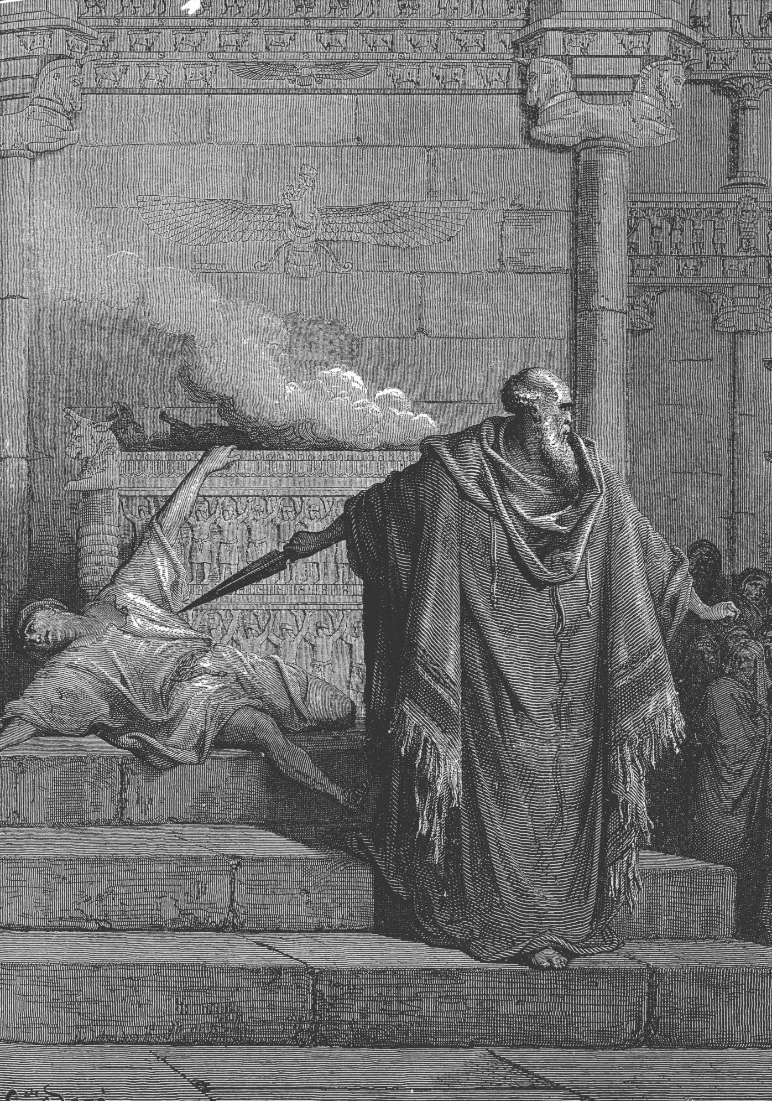

- Different reactions from the Jews:

    - The accommodators.

    - The pacifists.

    - The defenders.

    - The aggressors.

  - The Maccabean Revolt

- Modein (20 miles NW of Jer).

- Mattathias Hashmonai

Mattathias’s speech

- First 2 battles with the Syrian army: easy victories

      - Apollonius (3:10-12). Destroyed very easily; Judas takes his sword and uses it the rest of his life (3:12).

      - Seron (3:13-26). Though greatly outnumbered, Judas and his forces beat the Syrians, because “in the sight of Heaven there is no difference between saving by many or by few” (3:18).

- Next 2 battles with Syrians

      - A.E. hears about all that’s going on and he’s outraged (3:27). So he makes serious preparations to wipe out Judas and his forces, and all the Jews in Judea and Jerusalem (3:35). He musters up a huge army and places his general, Lysias, in charge (3:39), but he himself goes off to Persia to get more funds (3:37). Lysias chose 3 men to take care of the Jews: Ptolemy, Nicanor, and Gorgias (3:38).

      - Judas and his army also make preparations, but theirs has to do with prayer, fasting, supplication, and bible reading (3:42-53).

      - The 3rd battle is led by Gorgias with 4,000 men and 1,000 cavalry (4:1). Judas and his men have 3,000 fighters with no weapons! (4:6). They fought, nonetheless, appealing to the exodus account for divine support (4:8-11). Judas and his men crushed the Gentiles and took the plunder (4:12-25).

      - 1 year later (4:28), Lysias, was “perplexed and discouraged” (4:27) and musters up 60k men and 5k cavalry, while Judas had only 10k (4:28-29)! The Syrian army takes a huge blow, loosing 5k men (4:34), and so they pull back and head back to Antioch to enlist an even greater army (4:35).

      - During this time, while the Gentiles have been temporarily pushed out of the land, Judas and his followers cleanse the temple (4:36-61; 2 Macc 10:1-9).
Seleucid Rulers during the Maccabean Period

Antiochus III (223-187 BC): controlled Syria and Palestine as well as Mesopotamia and Media

Seleucus IV (187-175 BC): killed by his minister, heliodorus

Antiochus IV (175-164 BC): desecrated the alter/temple, persecuted the Jews leading to the Macc revolt

Antiochus V (164-162 BC): 9 years old when he began his reign; used as a royal front for Lysias

Demetrius (162-150 BC): son of Seleucus IV, escaped from Rome and acclaimed king

Demetrius II Nicator: (145-140 BC, and 129-126 BC): struggle for power.

  - Purification of the Temple

      - Tear down the alter that had been defiled (4:45-46), rebuild a new one according to the law (4:47-51), and cleansed and repaired the sanctuary.

          - restrained, but did not destroy, the Syrians in the citadel (4:41; cf. 6:18).

      - Then, on the 25th of Chislev (164 B.C.), the same day the alter was defiled (4:52-54), they offered sacrifice(s) on the new alter. After this, they celebrated for 8 days, in the spirit of the feast of booths (cf. 2 Macc 10:6). Judas and his brothers decide to make this a holiday, where Jews would remember the cleansing of the temple (4:59); hence, Hanukah.

      - Jewish Tradition on Hanukah:

- Judas’s Second Phase: Establish and Secure the Borders (1 Macc 5—7)

    - After Judas dedicates the alter and secures Jerusalem, he and his brothers engage in many battles with the neighboring peoples who begin to kill the Jewish population living in their midst.

      - they are called “Gentiles” (5:1) but many of these are semitic; Idumeans, descendants of Esau, and other nomadic people living in the land.

    - Galilee. 5:9-23

    - Gilead. 5:24-44

    - Hebron and Philistia. 5:65-68

    - Non-Hasmonean defeats: Joseph and Azariah (5:55-62).

    - Antiochus Epiphanes Dies (163 B.C.)

      - While in the east, he hears about what has happened in Israel (remember, he left Lysias in charge to wipe out the Jews, but hasn’t heard of all the stuff that has happened since!).

        - 1 Macc says that when he finds out about all that has happened, that he “became sick from disappointment, because things had not turned out for him as he had planned” (6:8).

      - 1 Macc 6:1-17; but a different version is retold in 2 Macc 9:1-29.

    - Judas takes the citadel; beat back by the Syrian army

      - The citadel was still occupied by the Syrians; so Judas and his army built siege engines and takes the citadel.

      - He then moves south and fortified Beth-Zur.

      - The Syrian army then marched on Beth-Zur with a massive army:
          - 120k infantry
          - 20k cavalry
          - 32 elephants “accustomed to war.”

      - Eleazar and the elephant!

      - Judas and his army ended up retreating, though this is hardly mentioned in the account (see 6:47).

    - Demetrius I takes control

        - Alcimus went to Demetrius I requesting to become the Jewish High Priest

        - At first, Alcimus seemed fairly godly, but later turned his back on the Jews and actually assassinated 60 “Hasideans,” pious aggressors who were the first to follow Judas (1 Macc. 7:12-16).

        - 1st battle.

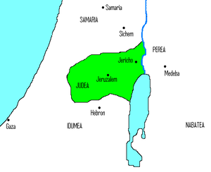
Figure 4 Judea under Judas

        - 2nd battle.

        - After this, Judas had made a treaty with Rome (1 Macc 8), though he wouldn’t see the help of Rome anytime soon.

        - Also, during this time, Judas began to loose his support.

- Jonathan succeeds Judas (160-142)

      - very important time; shift from __________________to _______________________.

      - God killed Alcimus

      - After Alcimus’s death, there are 7 silent years of which we no nothing about (159-152; cf. 9:58ff).

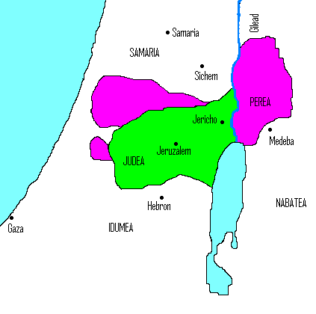
      - Balas, Demestius, and Jonathan.

        - “Had the revolutionary’s thirst for power made him forget the very principles that his family had been fighting for?” (Tomasino, 155).
Figure 5 Judea under Jonathan

“The king gave order to take off Jonathan’s garments and to clothe him in purple, and they did so. The king also seated him at his side; … When his accusers saw the honor that was paid him, in accord with the proclamation, and saw him clothed in purple, they all fled. Thus the king honored him and enrolled him among his chief Friends, and made him general and governor of the province. And Jonathan returned to Jerusalem in peace and gladness” (1 Macc 10:62-66).

  - Jonathan demonstrated his power and support for Balas by crushing Apollonius (gov of Demetrius II, who was contenting for the throne). He killed about 8k of his men, and as a result, Balas honored him even more (10:87-89).

  - In 145 B.C., Demetrius II overthrew Balas. While the transition was fresh, Jonathan once again laid siege to the citadel (Akra), which was still occupied by Syrian troops. Dem II got wind of it and met with Jonathan, but instead of a fight a truce was made (Both realized the benefit of a truce; the Syrian army was strong, yet Jonathan’s forces were tenacious). Jonathan lifted the siege and in return was exempt from paying taxes (11:34).

  - Another attempted coup: One of Balas’s generals, Tryphon, who put forth Antiochus VI. Demetrius enlisted Jonathan’s support, which he gladly gave and the revolt was put down. But Dem II went back on his promises, so Jonathan switch sides: he would now support Tryphon.

  - Antiochus VI through Tryphon took the throne. Jonathan, under the guise of supporting the Syrian king, continue to battle the Syrian forces that were loyal to Dem II. In doing so, he was showing support for Tryphon, but also securing the borders of Israel.

  - Jonathan then sent emissaries to Rome to secure their alliance that was made under Judas. Tryphon knew what Jonathan was doing, so he sent out to met him on friendly terms. He showerd him with praise and gifts and even gave him a city: Ptolemais. Jonathan went to see the city, but was then capture and held captive, while his men were slaughtered. Jonathan was later killed (142 B.C. 1 Macc 13:23) and his brother Simon would take over.

- Simon succeeds Jonathon (142—135)

  - Simon secured relative independence, the first time since pre-exilic Israel.

“In the 170th year (142 B.C.) the yoke of the Gentiles was removed from Israel, and the people began to write in their documents and contracts, ‘In the first year of Simon the great high priest and commander (strategos) and leader (hegoumenos) of the Jews’” (1 Macc. 13:41-42).

  - “Essentially, it (tax exemption) was a demand for autonomy. If the Jews paid no tribute, the Syrians gained no benefit from having them as subjects. The tribute was not only a source of revenue for the empire, it was a sin of submission. Simon was declaring his independence, and Demetrius was in no position to refuse” (Tomasino, 187).

  - Simon began to fortify the nation against future attacks.

  - In 140, the Jewish people as a whole recognized Simon’s leadership and authority and proclaimed him to be high priest, governor and supreme military commander (1 Macc 14:35). Moreover, this position was granted to Simon’s descendants after him. Thus, the Hasmonean dynasty was officially set up.

  - In 135 B.C., Simon was killed and his son John Hyrcanus (135-104) takes over as High Priest and leader.

  - 1 Maccabees thus ends.

- John Hyrcanus I (135-104)

      - Simon’s son

      - Syrian leadership would be in constant turmoil, allowing the Jews to enjoy a measure of independence (Tomasino, 191).

      - secured the eastern and northern borders of Judea

        - destroyed the Samaritan temple in the process (Tomasino, 192).

      - secured the southern border, forcing the Idumeans to either convert to Judaism or die (ironic: same as A.E. ??)

      - ended up establishing a large kingdom in Israel, the same size as Solomon’s (Tomasino, 194).

      - reaffirmed his alliance with Rome

      - minted coins for use in the land

      - never took the actual title “king,” even though he may have acted like one. This would be a huge violation, since he was not of Davidic descent.

      - when he died in 104, the Jewish nation was “as strong as any in its history” (Tomasino, 195).

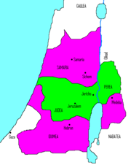
      - “But just as the kingdom of David and Solomon had enjoyed its success because of the relative weakness of Egypt and Assyria, John’s commonwealth could thrive only so long as the mighty empires around him were distracted by internal affairs” (Tomasino, 195).

      - Pharisees and Sadducees

Figure 6 Judea under John Hyrcanus

- Aristobulus I (104-103)

      - “unambiguously wicked” (Tomasino, 197).

      - Most significantly: he took the title “king,” thus combining the 2 offices of priest and king.

      - considered himself a “Greek lover” (philellen).

- Alexander Jannaeus (103-76)

      - Son of Hyrcanus, married Aristobulous’ widow, Alexandra Salome.

        - forbidden by Jewish law (Lev 21:10-14)
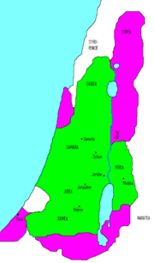

      - also took the title “king” as well as high priest.

      - at the Feast of Tabernacles = slaughtered 6,000 Jews!

      - 88 B.C. = 800 Pharisees crucified.

      - Also forced those whom he conquered to become Jews

Figure 7 Judea under Janneus

- Alexandra Salome (76-67)

      - became “queen” after her husband’s death

        - Hyrcanus II became high priest, and Aristobulus II commander of the army

      - peaceful reign

      - sided with the Pharisees

- Aristobulus II (67-63)

      - although Hyrcanus II was supposed to become king, Aristobulus II was much stronger.

      - at this time Antipater, the wealthy, influential, and corrupt governer of Idumea, along with Aretas III (king of Nabatea), convinced Hyrcanus II to take the throne.

      - Rome was moving West at this time. Aristobulus locked himself in the temple mount (a virtual fortress). Pompey, Roman General, perceive insubordination, laid siege to the temple. After 3 months, he broke through and slaughtered the priests and killed Aristobulus. Hyrcanus II was installed as high priest, but no more king. The 80 + years of independence had ended. Israel was again under the yoke of a Gentile power: Rome.

Outcome of the Hasmonean Dynasty

“So what did the Hasmoneans actually accomplish? Perhaps the most significant legacy of the Hasmoneans is the rebirth of Jewish nationalism. From 586 B.C. to 142 B.C. the Jews had been under the authority of foreign empires…The Jews were moving toward a complacent acceptance of their overlords’ cultures. But the Antiochan persecution and the Hasmonean revolt surely reversed that trend…Even if the Hasmonean dynasty had failed to be the kingdom that the prophets had envisioned, it whetted the nation’s appetite for the real thing. A renewed sense of Jewish destiny had been awakened, and it would not be quickly extinguished” (Tomasino, 211).

      - Wright mentions two primary results of the Maccabean revolt in general:

        - “It was, first, the backward reference-point for continued speculation about Israel’s eventual deliverance from pagan rule.” I.e. it fostered a continued sense of deliverance from pagan rule by means of revolt no matter how out-gunned they may be! God is on their side, so they thought.

        - “But the Maccabaean crisis was also, second, the cause of some of the divisions within Judaism” (Wright, People of God, 167).

